**Indira Gandhi Delhi Technical University for Women**

**(Established by Govt. of Delhi vide Act 09 of 2012)**

**Kashmere Gate, Delhi-110006**



**Practical File**

**for**

**Cyber Security**

**(MCA-207)**

**Submitted By: Submitted To:**

**Shweta Rawat Dr. Mohona Ghosh 06304092023 Assistant Professor**

**MCA 2nd year**

**(2023-2025)**

**Experiment 1**

Write a program to implement Shift Cipher taking set of English alphabets.

**CODE :**

#include <iostream>

#include <string>

using namespace std;

string encrypt(const string &plaintext, int shift) {

string ciphertext = "";

for (char c : plaintext) {

if (isalpha(c)) {

char base = isupper(c) ? 'A' : 'a';

ciphertext += (c - base + shift) % 26 + base;

} else {

ciphertext += c;

}

}

return ciphertext;

}

string decrypt(const string &ciphertext, int shift) {

string plaintext = "";

for (char c : ciphertext) {

if (isalpha(c)) {

char base = isupper(c) ? 'A' : 'a';

plaintext += (c - base - shift + 26) % 26 + base;

} else {

plaintext += c;

}

}

return plaintext;

}

int main() {

int choice, shift;

string input, result;

cout << "Shift Cipher Implementation\n";

cout << "1. Encrypt a message\n";

cout << "2. Decrypt a message\n";

cout << "Enter your choice (1 or 2): ";

cin >> choice;

cout << "Enter the shift value (0-25): ";

cin >> shift;

if (shift < 0 || shift > 25) {

cout << "Invalid shift value! Please enter a value between 0 and 25.\n";

return 1;

}

cin.ignore();

cout << "Enter the message: ";

getline(cin, input);

if (choice == 1) {

result = encrypt(input, shift);

cout << "Encrypted message: " << result << endl;

} else if (choice == 2) {

result = decrypt(input, shift);

cout << "Decrypted message: " << result << endl;

} else {

cout << "Invalid choice! Please select 1 or 2.\n";

}

return 0;

}

**OUTPUT :**

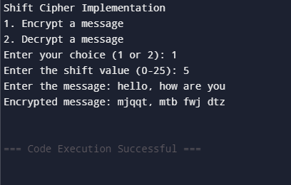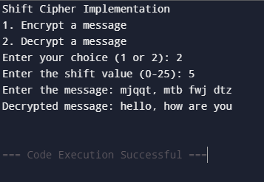

**Experiment 2**

Implement the following two cipher techniques via Python code for encryption and decryption of plain text. Substitution Cipher

**CODE :**

import string

def generate_substitution_key():

alphabet = string.ascii_lowercase

substitution_key = input("Enter a 26-character substitution key (unique letters only): ").lower()

if len(substitution_key) != 26 or not all(char in alphabet for char in substitution_key):

raise ValueError("Invalid key! Ensure it's 26 unique letters.")

return substitution_key

def encrypt_substitution_cipher(plaintext, substitution_key):

alphabet = string.ascii_lowercase

substitution_map = {alphabet[i]: substitution_key[i] for i in range(26)}

ciphertext = ""

for char in plaintext:

if char.isalpha():

if char.islower():

ciphertext += substitution_map[char]

else:

ciphertext += substitution_map[char.lower()].upper()

else:

ciphertext += char

return ciphertext

def decrypt_substitution_cipher(ciphertext, substitution_key):

alphabet = string.ascii_lowercase

reverse_map = {substitution_key[i]: alphabet[i] for i in range(26)}

plaintext = ""

for char in ciphertext:

if char.isalpha():

if char.islower():

plaintext += reverse_map[char]

else:

plaintext += reverse_map[char.lower()].upper()

else:

plaintext += char

return plaintext

def main():

print("Substitution Cipher Implementation")

print("1. Encrypt a message")

print("2. Decrypt a message")

choice = int(input("Enter your choice (1 or 2): "))

substitution_key = generate_substitution_key()

text = input("Enter the text: ")

if choice == 1:

result = encrypt_substitution_cipher(text, substitution_key)

print("Encrypted message:", result)

elif choice == 2:

result = decrypt_substitution_cipher(text, substitution_key)

print("Decrypted message:", result)

else:

print("Invalid choice!")

if __name__ == "__main__":

main()

**OUTPUT :**

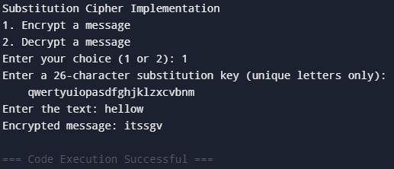

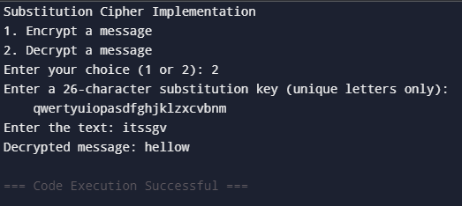

**Experiment 3**

Write a program to implement (both encryption and decryption) Vigenere Cipher. Take plaintext in form of small letters from user and output capital letters as ciphertext.Also take two choices - choice 1 for encryption and choice 2 for decryption.

**CODE :**

def vigenere_encrypt(plaintext, key):

ciphertext = ""

key = key.lower()

key_index = 0

for char in plaintext:

if char.islower():

shift = ord(key[key_index]) - ord('a')

new_char = chr((ord(char) - ord('a') + shift) % 26 + ord('A'))

ciphertext += new_char

key_index = (key_index + 1) % len(key)

else:

ciphertext += char

return ciphertext

def vigenere_decrypt(ciphertext, key):

plaintext = ""

key = key.lower()

key_index = 0

for char in ciphertext:

if char.isupper():

shift = ord(key[key_index]) - ord('a')

new_char = chr((ord(char) - ord('A') - shift + 26) % 26 + ord('a'))

plaintext += new_char

key_index = (key_index + 1) % len(key)

else:

plaintext += char

return plaintext

def main():

print("Vigenère Cipher Implementation")

print("1. Encrypt a message")

print("2. Decrypt a message")

choice = int(input("Enter your choice (1 or 2): "))

key = input("Enter the key (letters only): ")

if not key.isalpha():

print("Invalid key! Please enter only letters.")

return

text = input("Enter the text: ")

if choice == 1:

result = vigenere_encrypt(text, key)

print("Encrypted message:", result)

elif choice == 2:

result = vigenere_decrypt(text, key)

print("Decrypted message:", result)

else:

print("Invalid choice!")

if __name__ == "__main__":

main()

**OUTPUT :**

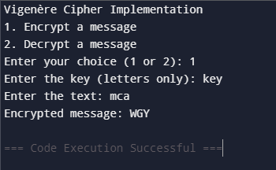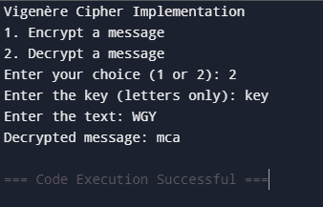

**Experiment 4**

Write a program to implement (both encryption and decryption) Transposition Cipher. Take plaintext in form of small letters from user and output capital letters as ciphertext.Also take two choices - choice 1 for encryption and choice 2 for decryption.

**CODE :**

#include <iostream>

#include <string>

#include <algorithm>

using namespace std;

// Function to encrypt using Transposition Cipher

string encryptTransposition(string plaintext, int key) {

int len = plaintext.length();

string ciphertext(len, ' ');

for (int i = 0; i < len; i++) {

ciphertext[(i * key) % len] = toupper(plaintext[i]);

}

return ciphertext;

}

// Function to decrypt using Transposition Cipher

string decryptTransposition(string ciphertext, int key) {

int len = ciphertext.length();

string plaintext(len, ' ');

for (int i = 0; i < len; i++) {

plaintext[i] = tolower(ciphertext[(i * key) % len]);

}

return plaintext;

}

int main() {

string inputText;

int choice, key;

cout << "Enter your choice:\n1. Encryption\n2. Decryption\n";

cin >> choice;

if (choice != 1 && choice != 2) {

cout << "Invalid choice. Please select 1 or 2.\n";

return 1;

}

cout << "Enter the key (an integer): ";

cin >> key;

if (choice == 1) {

cout << "Enter plaintext (in lowercase): ";

cin >> inputText;

string encryptedText = encryptTransposition(inputText, key);

cout << "Ciphertext (in uppercase): " << encryptedText << endl;

} else if (choice == 2) {

cout << "Enter ciphertext (in uppercase): ";

cin >> inputText;

string decryptedText = decryptTransposition(inputText, key);

cout << "Decrypted plaintext (in lowercase): " << decryptedText << endl;

}

return 0;

}

**OUTPUT :**

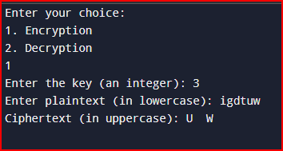

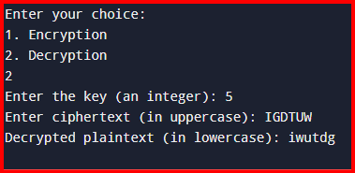

**Experiment 5**

Using RSA algorithm, implement digital signatures

1. Display public and private key pair of two participants Alice and Bob
2. Based on the public private key pair, perform
   1. Sign-then-encrypt : First encrypt the message using private key of Alice followed by encryption using public key of Bob
   2. Encrypt-then-sign: First encrypt the message using public key of Bob followed by encryption using private key of Alice
3. Perform decryption for both cases.

**CODE :**

#include <iostream>

#include <cmath>

#include <string>

#include <tuple>

using namespace std;

// Function to calculate greatest common divisor (GCD)

int gcd(int a, int b) {

while (b != 0) {

int temp = b;

b = a % b;

a = temp;

}

return a;

}

// Function to calculate modular exponentiation (base^exp % mod)

long long modExp(long long base, long long exp, long long mod) {

long long result = 1;

while (exp > 0) {

if (exp % 2 == 1) {

result = (result * base) % mod;

}

base = (base * base) % mod;

exp /= 2;

}

return result;

}

// RSA Key Generation

tuple<int, int, int> generateRSAKeys() {

int p = 61, q = 53; // Two prime numbers (example values)

int n = p * q; // Public modulus

int phi = (p - 1) * (q - 1);

// Find public key `e` such that 1 < e < phi and gcd(e, phi) = 1

int e = 3;

while (gcd(e, phi) != 1) {

e++;

}

// Find private key `d` such that (d * e) % phi = 1

int d = 1;

while ((d * e) % phi != 1) {

d++;

}

return make_tuple(n, e, d); // Return n (modulus), e (public key), and d (private key)

}

// Sign the message using the sender's private key

long long signMessage(int message, int privateKey, int modulus) {

return modExp(message, privateKey, modulus);

}

// Encrypt the message using the receiver's public key

long long encryptMessage(int message, int publicKey, int modulus) {

return modExp(message, publicKey, modulus);

}

// Decrypt the message using the receiver's private key

long long decryptMessage(long long encryptedMessage, int privateKey, int modulus) {

return modExp(encryptedMessage, privateKey, modulus);

}

// Workflow: Sign-then-encrypt and Encrypt-then-sign

int main() {

// Generate keys for Alice and Bob

auto [nAlice, eAlice, dAlice] = generateRSAKeys();

auto [nBob, eBob, dBob] = generateRSAKeys();

cout << "Alice's Public Key (e, n): (" << eAlice << ", " << nAlice << ")\n";

cout << "Alice's Private Key (d, n): (" << dAlice << ", " << nAlice << ")\n";

cout << "Bob's Public Key (e, n): (" << eBob << ", " << nBob << ")\n";

cout << "Bob's Private Key (d, n): (" << dBob << ", " << nBob << ")\n\n";

// Message to be sent (numeric value for simplicity)

int message = 89;

cout << "Original Message: " << message << "\n\n";

// Sign-then-encrypt

cout << "Sign-then-encrypt:\n";

long long signedMessage = signMessage(message, dAlice, nAlice);

long long encryptedMessageSTE = encryptMessage(signedMessage, eBob, nBob);

cout << "Signed Message: " << signedMessage << "\n";

cout << "Encrypted Message (Sign-then-encrypt): " << encryptedMessageSTE << "\n";

// Decryption for Sign-then-encrypt

long long decryptedSTE = decryptMessage(encryptedMessageSTE, dBob, nBob);

long long verifiedSTE = decryptMessage(decryptedSTE, eAlice, nAlice);

cout << "Decrypted Message (Sign-then-encrypt): " << verifiedSTE << "\n\n";

// Encrypt-then-sign

cout << "Encrypt-then-sign:\n";

long long encryptedMessage = encryptMessage(message, eBob, nBob);

long long signedMessageETS = signMessage(encryptedMessage, dAlice, nAlice);

cout << "Encrypted Message: " << encryptedMessage << "\n";

cout << "Signed Message (Encrypt-then-sign): " << signedMessageETS << "\n";

// Decryption for Encrypt-then-sign

long long verifiedETS = decryptMessage(signedMessageETS, eAlice, nAlice);

long long decryptedETS = decryptMessage(verifiedETS, dBob, nBob);

cout << "Decrypted Message (Encrypt-then-sign): " << decryptedETS << "\n";

return 0;

}

**OUTPUT :**

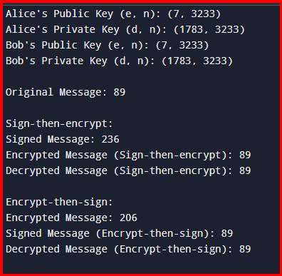

**Experiment 6**

Read cuckoo hashing from “geekeforgeeks” and implement cuckoo hashing using hash functions given on <https://www.geeksforgeeks.org/cuckoo-hashing/>

**CODE :**

#include <iostream>

#include <vector>

#include <cmath>

#include <cstring>

using namespace std;

const int MAX_REHASHES = 10; // Maximum rehash attempts

const int TABLE_SIZE = 11; // Size of the hash tables

class CuckooHashing {

private:

vector<int> table1, table2; // Two hash tables

int size; // Current number of elements

// Hash functions

int h1(int key) {

return key % TABLE_SIZE;

}

int h2(int key) {

return (key / TABLE_SIZE) % TABLE_SIZE;

}

// Rehash the entire table when a cycle occurs

void rehash() {

cout << "Rehashing..." << endl;

vector<int> oldTable1 = table1;

vector<int> oldTable2 = table2;

table1.assign(TABLE_SIZE, -1);

table2.assign(TABLE_SIZE, -1);

size = 0;

// Reinsert elements into new tables

for (int key : oldTable1) {

if (key != -1)

insert(key);

}

for (int key : oldTable2) {

if (key != -1)

insert(key);

}

}

public:

// Constructor

CuckooHashing() : size(0) {

table1.assign(TABLE_SIZE, -1);

table2.assign(TABLE_SIZE, -1);

}

// Insert a key into the hash table

void insert(int key) {

if (lookup(key)) {

cout << "Key " << key << " already exists." << endl;

return;

}

int cycleCheck = 0;

int currentKey = key;

for (int attempts = 0; attempts < MAX_REHASHES; ++attempts) {

int pos1 = h1(currentKey);

// Try inserting into table1

if (table1[pos1] == -1) {

table1[pos1] = currentKey;

++size;

return;

}

// Displace the key from table1

swap(currentKey, table1[pos1]);

int pos2 = h2(currentKey);

// Try inserting into table2

if (table2[pos2] == -1) {

table2[pos2] = currentKey;

++size;

return;

}

// Displace the key from table2

swap(currentKey, table2[pos2]);

if (++cycleCheck > size) {

rehash();

insert(key);

return;

}

}

// If insertion fails after MAX_REHASHES, rehash

rehash();

insert(key);

}

// Delete a key from the hash table

void remove(int key) {

int pos1 = h1(key);

if (table1[pos1] == key) {

table1[pos1] = -1;

--size;

cout << "Key " << key << " deleted from table1." << endl;

return;

}

int pos2 = h2(key);

if (table2[pos2] == key) {

table2[pos2] = -1;

--size;

cout << "Key " << key << " deleted from table2." << endl;

return;

}

cout << "Key " << key << " not found." << endl;

}

// Lookup a key in the hash table

bool lookup(int key) {

int pos1 = h1(key);

if (table1[pos1] == key)

return true;

int pos2 = h2(key);

if (table2[pos2] == key)

return true;

return false;

}

// Display the hash tables

void display() {

cout << "Table 1: ";

for (int i = 0; i < TABLE_SIZE; ++i) {

if (table1[i] != -1)

cout << table1[i] << " ";

else

cout << "- ";

}

cout << endl;

cout << "Table 2: ";

for (int i = 0; i < TABLE_SIZE; ++i) {

if (table2[i] != -1)

cout << table2[i] << " ";

else

cout << "- ";

}

cout << endl;

}

};

// Driver code

int main() {

CuckooHashing hashTable;

vector<int> keys = {20, 50, 53, 75, 100, 67, 105, 3, 36, 39};

for (int key : keys) {

cout << "Inserting " << key << "..." << endl;

hashTable.insert(key);

hashTable.display();

}

cout << "\nLooking up 53: " << (hashTable.lookup(53) ? "Found" : "Not Found") << endl;

cout << "Looking up 200: " << (hashTable.lookup(200) ? "Found" : "Not Found") << endl;

cout << "\nDeleting 53..." << endl;

hashTable.remove(53);

hashTable.display();

return 0;

}

**OUTPUT :**

